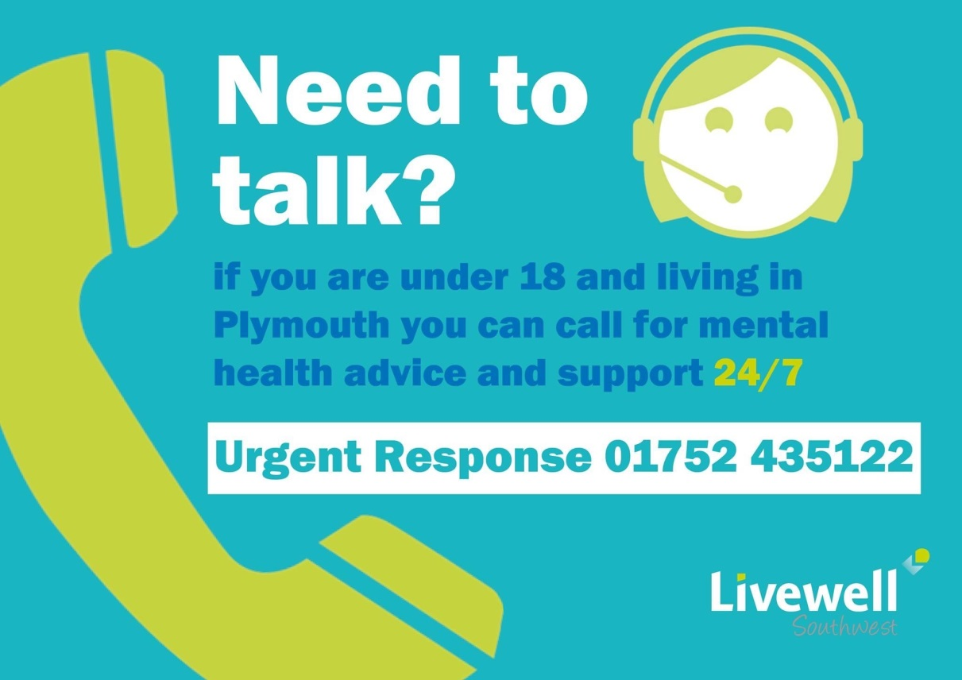
Barnardo’s HYPE
https://www.facebook.com/HYPEplymouth/
https://www.hypeplymouth.com/

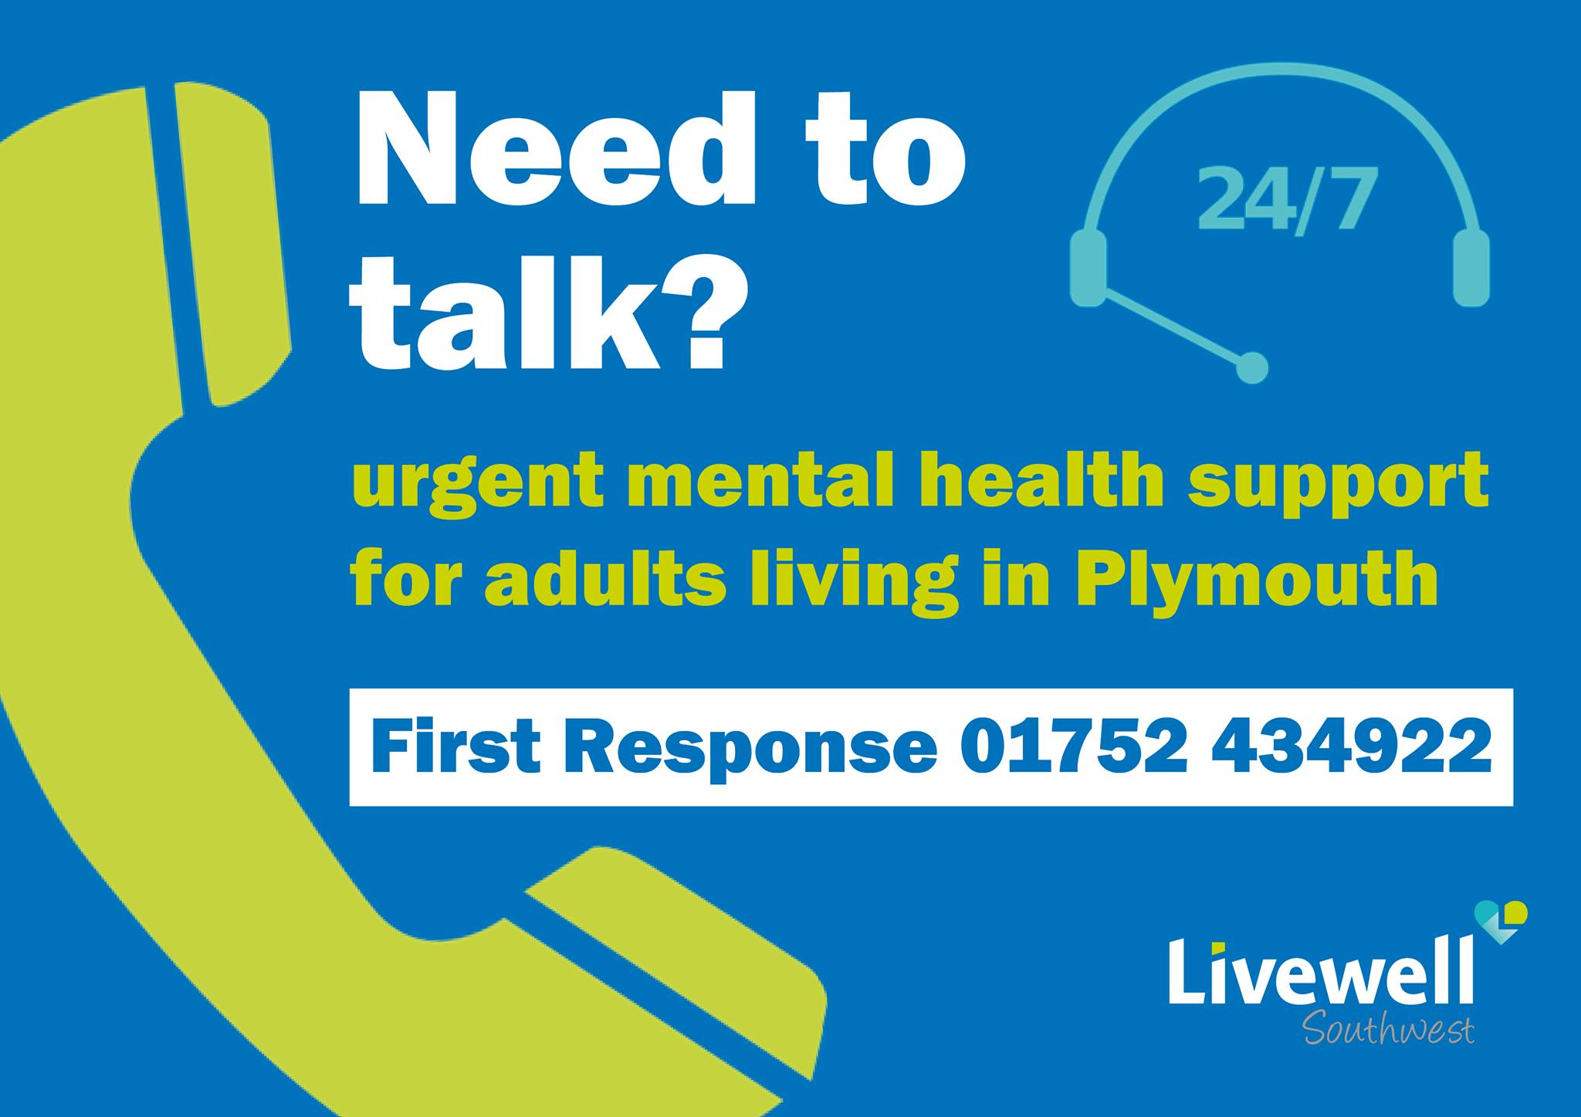
Livewell Southwest Academy will be running a free Understanding Mental Health and Wellbeing course in January which supports the Workplace Wellbeing Charter Requirements
https://www.livewellswacademy.co.uk/course/understanding-mental-health-and-wellbeing/

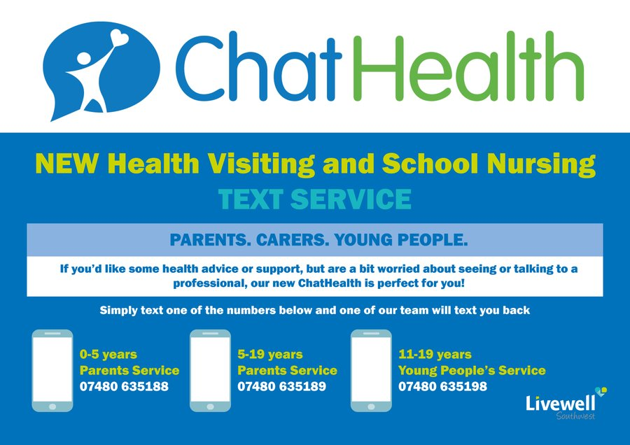



CAMHS Community Team Duty Advice line for Families and Professionals has extended its opening hours in response to COVID-19. The phone line is now open Monday – Friday from 9am to 5pm. Please contact the team on 01752 431613 to seek advice, discuss whether a referral to CAMHS may be appropriate and access support for families who are currently awaiting input from the CAMHS Community Team.

Mental Health Support Team
Livewell Southwest has successfully secured funding to establish a Mental Health Support Team. This is a pilot scheme with identified schools to evaluate the effectiveness of school based interventions to support children, young people, families and professionals to promote emotional health and wellbeing.
The team will be offering a range of support including working with anxiety, low mood, behavioural concerns, peer mentoring and parenting interventions.
Requests for training and consultation can be made directly to the team.

Contact
Tel: 01752 435401
Email: livewell.mhst@nhs.net

The following schools are currently involved in the pilot.
Austin Farm Academy
Ford Primary School
High Street Primary
Knowle Primary School
Leigham Primary School
Lipson Co-operative Academy
Lipson Vale Primary School
Marlborough Primary School
Morice Town Primary Academy
Mount Street Primary School
Mount Wise Community Primary School
Plympton Academy
Shakespeare Primary School
Sir John Hunt Community Sports College
St George’s Church of England Primary Academy
St Joseph’s Catholic Primary School
St Peter’s Church of England Primary
Stoke Damerel Community College
The Cathedral School of St Mary
Tor Bridge High
Whitleigh Community Primary School
Woodfield Primary School



